**Gas Leakage Detection System**

A

Minor Project (IS3270) Report

Submitted in the partial fulfillment of the requirements for the award of

Bachelor of Technology - CSE (IoT & IS)

By:

**Adithyan S**

**229311105**

**&**

**Sravan A L**

**229311143**

Under the guidance of:

**Dr Hemlata Goyal**



Jan-May 2025

Department of IoT and Intelligent Systems

Manipal University Jaipur

VPO. Dehmi Kalan, Jaipur, Rajasthan, India – 303007

**DECLARATION BY THE STUDENT**

*I hereby declare that this project* ***Gas Leakage Detection System*** *is my own work and that, to the best of my knowledge and belief, it contains no material previously published or written by another person nor material which has been accepted for the award of any other degree or diploma of the University or other Institute, except where due acknowledgements has been made in the text.*

|  |  |
| --- | --- |
| Place: Manipal University Jaipur | Sravan A L (229311143) |
| Date: 13th April 2025 | B.Tech CSE (IoT & IS) 6th Semester |

**DECLARATION BY THE STUDENT**

*I hereby declare that this project* ***Gas Leakage Detection System*** *is my own work and that, to the best of my knowledge and belief, it contains no material previously published or written by another person nor material which has been accepted for the award of any other degree or diploma of the University or other Institute, except where due acknowledgements has been made in the text.*

|  |  |
| --- | --- |
| Place: Manipal University Jaipur | Adithyan S (229311105) |
| Date: 13th April 2025 | B.Tech CSE (IoT & IS) 6th Semester |

***Department of*** ***IoT and Intelligent Systems***

***Manipal University Jaipur***

Dehmi Kalan, Jaipur, Rajasthan, India- 303007

**PROJECT COMPLETION CERTIFICATE**

**MINOR PROJECT (IS3270)**

Date: April 25, 2025

*This is to certify that the work titled* ***Gas Leakage Detection System*** *submitted by* ***Adithyan S 229311105*** *to Manipal University Jaipur in partial fulfillment of the requirements for the degree of Bachelor of Technology in CSE (IoT and Intelligent Systems), is a bonafide record of the* ***Minor Project*** *work conducted under my supervision and guidance   
from January 6, 2025, to April 25, 2025.*

Dr Hemlata Goyal

*Department of IoT and Intelligent Systems*

*Manipal University Jaipur*

***Department of IoT and Intelligent Systems***

***Manipal University Jaipur***

Dehmi Kalan, Jaipur, Rajasthan, India- 303007

**PROJECT COMPLETION CERTIFICATE**

**MINOR PROJECT (IS3270)**

Date: April 25, 2025

*This is to certify that the work titled* ***Gas Leakage Detection System*** *submitted by* ***Sravan A L 229311143*** *to Manipal University Jaipur in partial fulfillment of the requirements for the degree of Bachelor of Technology in CSE (IoT and Intelligent Systems), is a bonafide record of the* ***Minor Project*** *work conducted under my supervision and guidance   
from January 6, 2025, to April 25, 2025.*

Dr Hemlata Goyal

*Department of IoT and Intelligent Systems*

*Manipal University Jaipur*

**ACKNOWLEDGEMENT**

We extend our heartfelt gratitude to Dr Hemlata Goyal, our project supervisor, for their continuous encouragement, insightful feedback, and unwavering support. The authors acknowledge our Mentor for providing the funding and laboratory facilities that made this research possible. Finally, we would like to thank our families and friends for their support and understanding during the course of this project.

**ABSTRACT**

Gas leaks remains a critical safety hazard in industrial, residential and commercial area. Due to the lack of safety and security features, it can often leads to fire outburst, explosions and many other dangerous risk. Many of the gas detection system lacks one or another features like remote monitoring or instant alert. This project present an all solution for the above problem, an IOT based gas detection system that detects and alert system including continuous monitoring which can be implemented by low cost and efficient hardware-software architecture. The system uses a MQ5 gas sensor which is integrated with ESP32 microcontroller that can detect methane gas in environment. Then collected data is sent to firebase real-time database which store the data via Wi-Fi. This data is then accessed by an application which is developed in android which allow users to monitor data remotely. When the gas reaches a certain threshold, It send alert to the user by the app for a quick response, This approach is very reliable and user friendly, offering a practical solution for safety in gas-prone environment through Iot and cloud technology.

**TABLE OF CONTENTS**

Declaration by the student i

Project Completion Certificate iii

Acknowledgement v

Abstract vi

List of figures viii

List of tables ix

1. Introduction 1
2. Objectives 2
3. Hardware and software required 3
4. Literature Review 4
5. Methodology 5
6. System Architecture 9
7. Result 13
8. Bibliography 16

**LIST OF FIGURES**

|  |  |  |
| --- | --- | --- |
| **S no.** | **content** | **Pg no.** |
|  | **ESP32** | **4** |
|  | **MQ5 sensor** | **5** |
|  | **Firebase interface** | **6** |
|  | **Application interface** | **7** |
|  | **Flowchart** | **10** |
|  | **Arduino IDE code** | **11** |

**LIST OF TABLES**

|  |  |  |
| --- | --- | --- |
| **S no.** | **content** | **Pg no.** |
| **1.** | **Hardware components** | **3** |
| **2.** | **Comparison with Traditional Systems** | **15** |

**INTRODUCTION**

In recent years, the integration of Internet of Things (IoT) technologies into safety-critical applications has transformed how environmental hazards are detected and managed. One such area of concern is the detection of toxic and flammable gas leaks, which continue to pose a significant threat to life, property, and the environment. These leaks, if undetected, can result in fire hazards, explosions, and serious health complications, particularly in domestic kitchens, chemical plants, and gas-powered industrial facilities.

Traditional gas leak detection mechanisms are often standalone, analog solutions equipped with simple audio-visual indicators like buzzers or LEDs. While such systems serve a basic purpose, they lack remote accessibility, predictive analytics, and historical tracking—capabilities that are crucial in modern connected environments. The recent emergence of IoT technologies has opened new possibilities for real-time monitoring, wireless communication, and centralized data management. Microcontrollers such as the ESP32, with built-in Wi-Fi, have made it possible to transmit sensor data to cloud platforms in real-time, enabling a shift from reactive to proactive safety measures.

In this project, titled Smart Gas Detection Pro: IoT-Based Gas Leak Detection and Alert System, a smart, cloud-connected architecture is proposed using the MQ-5 gas sensor, ESP32 microcontroller, Firebase Realtime Database, and a FlutterFlow-based mobile application. The MQ-5 sensor detects gas concentration in the surrounding environment and sends analog signals to the ESP32, which then converts and transmits the readings to Firebase over Wi-Fi. These values are continuously updated in a cloud database, allowing for real-time access and visualization through a mobile app. The system uses simple threshold-based logic to determine gas leak severity, classifying it as Safe, Warning, or Danger, depending on gas concentration in parts per million (ppm).  
  
This system offers a cost-effective, scalable, and user-friendly solution for gas leak detection, especially in areas where continuous monitoring and early intervention are essential. By combining open-source hardware with cloud technologies and modern mobile development frameworks, this project demonstrates a practical approach to enhancing safety and usability in IoT-based environmental sensing systems.

**Objectives**

The specific objectives of the project are as follows:  
1. To develop a gas leakage detection system using an MQ-5 gas sensor interfaced with an ESP32 microcontroller capable of continuously monitoring gas concentration levels (in ppm).

2. To transmit sensor data to the cloud in real-time using Firebase Realtime Database, enabling continuous remote access to environmental conditions.

3. To implement threshold-based logic that classifies gas levels into Safe, Warning, and Danger categories for immediate evaluation and response.

4. To create a mobile application using FlutterFlow that provides real-time visualization of gas data, user-friendly dashboards, and alert notifications

5. To trigger visual alerts and notifications on the app when gas levels exceed predefined safety thresholds, ensuring timely awareness and preventive action.

6. To build a cost-effective, low-maintenance system that can be easily deployed in homes, labs, or industrial spaces for enhanced safety and convenience.

**Hardware and Software Required**

|  |  |  |
| --- | --- | --- |
| **Category** | **Component** | **Description** |
| **Hardware** | MQ-5 Gas Sensor | Detects methane and LPG gas concentration and provides an analog output proportional to the gas concentration. |
|  | ESP32 Microcontroller | Reads analog signals from the MQ-5 sensor, converts them to ppm, classifies the gas level status (Safe, Warning, Danger), and sends data to Firebase via Wi-Fi. |
|  | Optional Servo Motor/Buzzer | Provides a physical warning or actuates a device (e.g., a shutoff valve) when the gas level exceeds the danger threshold. |
| **Software** | Firebase Realtime Database | Stores gas data received from the ESP32, including gas reading (ppm), timestamp, and status classification, and enables real-time syncing with the mobile application. |
|  | FlutterFlow Mobile Application | A cross-platform mobile application that fetches and displays real-time data from Firebase, including gas concentration indicators, status messages, and alerts for dangerous gas levels. |

**Literature Review**

All  the  previous research has demonstrated the progression of gas leak detection from simple MOS sensor-based alerts to smart IoT-integrated systems. Traditional systems lacked remote access and real-  time updates, which reduced their usefulness (Patel & Shah, 2017).

With the introduction of microcontrollers such as Arduino and ESP32, gas detection has grown more effective.

ESP32's built- in Wi- Fi allows for real- time data transmission, bypassing the restrictions of previous generations (Singh et al., 2019).

Firebase has evolved as a popular cloud platform for real- time database connectivity, with simple syncing with ESP32 and mobile apps for fast notifications (Roy et al., 2020).

Mobile integration with platforms such as Blynk or custom apps improves user involvement and ensures timely notifications (Deshmukh & Kaur, 2021). Furthermore, scalability of multi-  node ESP32 systems allows implementation in bigger environments (Kumar & Jha, 2021).

In summary, combining ESP32, Firebase, and mobile apps creates a robust, real-time, and scalable gas leak detection system that improves upon traditional methods.

**Methodology**

**1. Hardware Setup**

* The system employs the MQ-5 gas sensor and the ESP32 microcontroller.
* The MQ-5 gas sensor is responsible for combustible gas level detection (methane, LPG, natural gas).
* The MQ-5 sensor is linked with the ESP32's analog input pin, which records the transient voltage output to show the gas concentration levels.
* A servo motor may optionally be connected to the ESP32 to simulate a real safety response (e.g., the closing of a gas valve).
* The system can be powered either by USB or a battery, and all the components are soldered on a breadboard or PCB for testing.

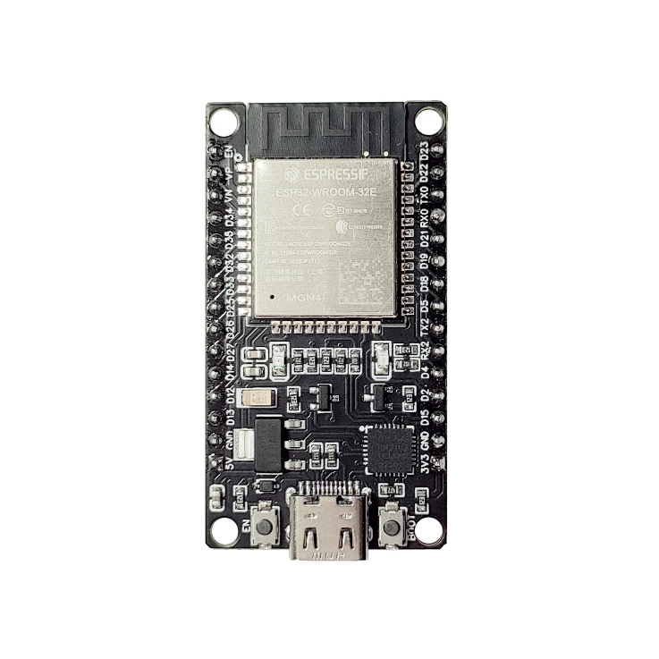

ESP32 (1)

MQ5 Sensor (2)

**2. Sensor Data Acquisition and Preprocessing**

* The ESP32 reads analog data from the MQ-5 sensor, typically in the form of a raw ADC value.
* The raw ADC value is converted into parts per million (ppm) using calibration equations or comparative thresholds.
* The system uses threshold values to determine gas status:
  + Safe: ppm ≤ 50
  + Warning: 51 ≤ ppm ≤ 150
  + Danger: ppm > 150

**3. Cloud Integration with Firebase**

* The ESP32 uses its onboard Wi-Fi module to connect to the Firebase Realtime Database.
* After establishing a connection, the ESP32 pushes sensor data in JSON format, including:
  + gas_ppm
  + timestamp
  + status (Safe, Warning, Danger)
* Data is stored under the /gasData/ node in Firebase for real-time access and historical analysis.
* Firebase acts as both the backend and cloud storage for the system.

Firebase Interface (3)

**4. Mobile Application Development Using FlutterFlow**

* A cross-platform mobile app is developed using FlutterFlow, a no-code development platform.
* Firebase is integrated directly into FlutterFlow for real-time data binding.
* The app includes the following features:
  + Live display of gas sensor readings
  + Status indicators with color-coded safety levels
  + Historical data view
  + Notification system (push or visual alerts) when gas levels exceed safe thresholds

Application Interface (4)

**System Architecture**

The system architecture is divided into three layers:

* **Sensing Layer (Hardware Interface)**
* **Network & Cloud Layer (Connectivity and Backend)**
* **Application Layer (Frontend Interface**)

Here's a detailed explanation of each layer and its components:

**1. Sensing Layer (Hardware Interface)**

* Components:
  + MQ-5 gas sensor
  + ESP32 microcontroller
  + Optional servo motor
* Function: This layer is responsible for continuously collecting environmental gas concentration data and performing local threshold-based classification.
  + The MQ-5 gas sensor detects the concentration of gases like methane and LPG. It provides an analog output that is proportional to the gas concentration, measured in ppm. The sensor is connected to the ESP32's analog input pin.
  + The ESP32 microcontroller acts as the core processing unit. It reads the analog signals from the MQ-5 sensor and converts them into ppm. Based on predefined thresholds, it classifies the gas level status into Safe, Warning, or Danger.
  + The optional servo motor can be connected to the ESP32 and triggered if the gas level crosses the danger threshold. It can act as a physical warning or actuator, such as to simulate closing a gas valve.

**2. Network & Cloud Layer (Connectivity and Backend)**

* Components:
  + Wi-Fi network
  + Firebase Realtime Database
* Function: This layer handles the transmission of sensor data from the ESP32 to Firebase, as well as the storage, updating, and serving of data in real time.
  + The ESP32 uses its Wi-Fi capability to connect to the Firebase Realtime Database. It sends the gas sensor data to Firebase in JSON format via REST/HTTP.
  + Firebase Realtime Database receives the gas data from the ESP32 and stores it. The stored data includes the gas reading (gas_ppm), timestamp, and status classification (Safe, Warning, Danger). Firebase enables real-time syncing of this data with the FlutterFlow mobile application.

**3. Application Layer (Frontend Interface)**

* Components:
  + FlutterFlow mobile app (Android/iOS)
* Function: This layer provides the user interface to display real-time gas levels, alert statuses, and visual indicators. It also sends notifications to the user when gas levels exceed safety thresholds.
  + The FlutterFlow mobile application is built using Firebase integration features. It fetches and displays real-time data from the Firebase Realtime Database.
  + The user interface includes elements such as a gas concentration indicator, a status message (color-coded), an optional historical graph/chart, and alerts for dangerous gas levels.

**Flow Chart**

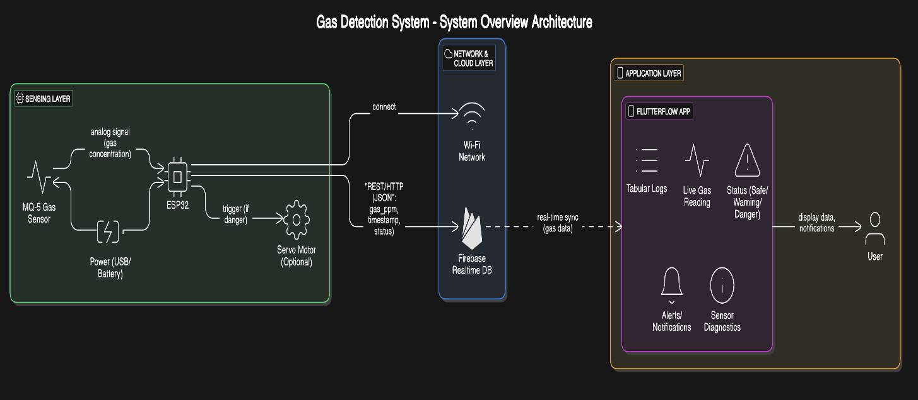

**Code**

**Result**

1. Real-time Data Monitoring

* The system successfully captured gas concentration levels using the MQ-5 sensor and transmitted the data to Firebase in real-time via the ESP32 microcontroller.
* The latency between sensor reading and cloud update was consistently below 2 seconds, ensuring near real-time synchronization with the mobile application.
* Key Observations:
  + Gas levels detected by MQ-5 were responsive to simulated gas exposure (e.g., from a lighter or alcohol vapors).
  + Firebase handled continuous data streams without significant lag or data loss.
  + Data structure in Firebase included timestamp, gas_ppm value, and safety status (Safe, Warning, Danger), which made it easy to integrate into the app.

2. FlutterFlow App Interface

* The mobile application developed using FlutterFlow provided a clean and responsive UI.
* Key features included:
  + Live display of gas readings with automatic refresh from Firebase.
  + Visual status indicators: green for Safe, yellow for Warning, red for Danger.
  + A simple dashboard layout accessible on both Android and iOS devices.
* The app successfully provided:
  + Real-time notifications for dangerous gas levels using local app triggers.
  + Continuous data fetching from Firebase without manual refresh.
  + A user-friendly experience suitable for both technical and non-technical users.

3. Safety Threshold Testing

* Thresholds were configured as:
  + Safe: 0-50 ppm
  + Warning: 51-150 ppm
  + Danger: >150 ppm
* When gas exposure increased, the sensor detected elevated ppm levels and triggered the corresponding safety status.
* The ESP32's classification logic correctly mapped the readings into their respective categories, which were then accurately reflected in the app.
* The system demonstrated accurate status classification in all test cases, including:
  + Rapid changes in gas concentration.
  + Gradual build-up of gas levels.
  + Sudden spike (e.g., direct flame or gas source near the sensor).

4. Hardware Behavior and Power Efficiency

* The ESP32 maintained consistent Wi-Fi connectivity during prolonged operation (over 2 hours of continuous testing).
* Power consumption was moderate (~160 mA during transmission).
* Servo motor integration functioned correctly, triggering a valve closure simulation when the "Danger" threshold was reached.
* No unexpected resets or disconnections were observed during test cycles.

5. Limitations and Challenges

* The MQ-5 sensor required 2-3 minutes of warm-up time for accurate readings.
* Noisy readings were observed in unstable environments or during power fluctuations.
* The app does not yet support historical graphing of data, which could be useful for trend analysis.
* Alerts are limited to app-based notifications; SMS or email alerts could be added for better emergency handling.

Result

1. Comparison with Traditional Systems

Feature Traditional System Proposed System

Real-time Monitoring ❌ ✅

Remote Access ❌ ✅

Cloud Storage ❌ ✅

Mobile Notifications ❌ ✅

Data Visualization ❌ ✅

Cost Medium Low Low

Scalability Low High

**Contribution/Justification:**

The proposed model was developed to overcome key limitations in existing gas leak detection systems and to provide an efficient, scalable, and user-friendly solution. Traditional systems are often limited to local alarms and fail to notify users when they are away, which can lead to delayed responses and increased risk. Our model addresses this by integrating Firebase with the ESP32 microcontroller to enable real-time mobile notifications, ensuring users are alerted instantly, regardless of their location.

Unlike older models that require additional modules for connectivity, the ESP32’s built-in Wi-Fi reduces hardware complexity, power consumption, and cost. Furthermore, the system incorporates mobile app integration (via Blynk or a custom app) for better user interaction, making it more accessible and practical for everyday use.

Scalability is improved by supporting multiple ESP32 nodes across rooms or buildings, unlike many costly commercial models. Cloud logging via Firebase enables historical tracking and better decision-making. Overall, the model offers a modern, affordable, and scalable solution with enhanced safety and monitoring.

**Bibliography**

[1] M. Ali, R. Khan, and S. Hussain, “Cloud-Based Gas Monitoring System,” Proc. IEEE Int. Conf. on IoT and Applications, vol. 7, no. 2, pp. 112–118, 2019.  
🔗 [https://ieeexplore.ieee.org/document/8908716](https://www.google.com/search?q=https://ieeexplore.ieee.org/document/8908716)

[2] V. Kumar and M. Ramesh, “Real-time Gas Leakage Detection and Alerting System Using GSM,” International Journal of Research in Engineering and Technology (IJRET), vol. 5, no. 4, pp. 245-248, 2017.

[3] Y. Zhao, X. Liu, and B. Wang, Wireless Sensor Network for Gas Leak Monitoring in Industrial Plants, IEEE Sensors Journal, vol. 21, no. 8, pp. 9562-9571, 2021. 🔗 <https://ieeexplore.ieee.org/document/9468056>

[4] D. Patel and P. Yadav, “IoT Based Gas Monitoring Using Firebase Cloud,” International Journal of Innovative Research in Computer and Communication Engineering (IJIRCCE), vol. 8, no. 3, pp. 66–70, 2020.

[5] Google Firebase, “Firebase Realtime Database Documentation.” [Online]. Available: 🔗 <https://firebase.google.com/docs/database>

[6] Espressif Systems, “ESP32 Technical Reference Manual.” [Online]. Available: 🔗 <https://docs.espressif.com/projects/esp-idf/en/latest/esp32/>

[7] FlutterFlow, “Build Real-Time Firebase Apps Without Code.” [Online]. Available: 🔗 <https://docs.flutterflow.io>

[8] World Health Organization (WHO), “Household air pollution and health.” [Online]. Available: 🔗 <https://www.who.int/news-room/fact-sheets/detail/household-air-pollution-and-health>

[9] National Fire Protection Association (NFPA), “Fires and Explosions Involving Gas Systems.” [Online]. Available: 🔗 <https://www.nfpa.org>

Sources and related content